One of the products that I researched for my project was a stylized forest asset pack by Synty studios.

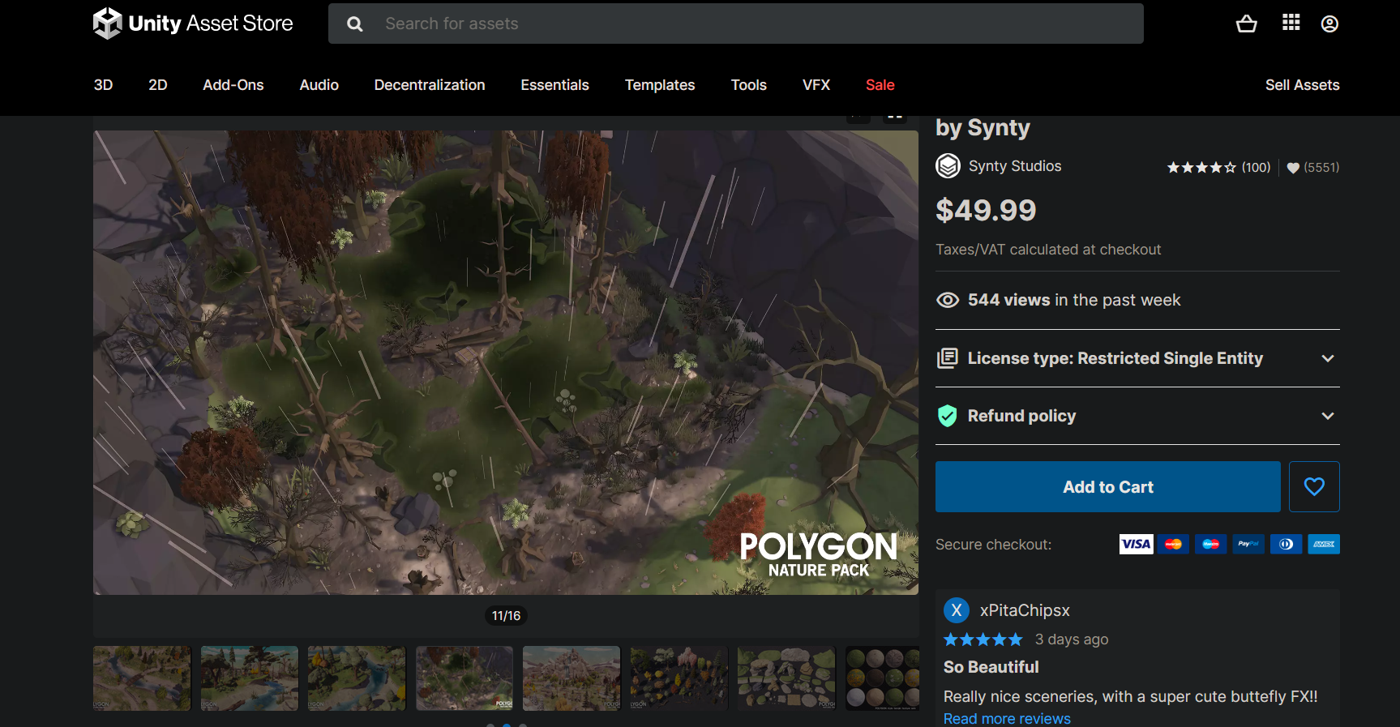

• Supported Platforms: Windows and MacOS

• Supported Unity Versions: 2019.4.28 or higher

• Download Type: Asset Pack

* Review: The asset packs include low poly trees, plains, terrain, rocks, and so on. It fits a variety of aesthetics and spans the gap between polygonal and more traditional styled components. It is a complex landscape texture with clean tiling normal maps that may be dynamically lighted which is also included in the collection. The asset pack also includes animated plants and trees. Unity makes it simple to customize. It also provides the user with a customizable stylized water shader of their choice. The pack also includes fantastic particle effects such as grass blowing, butterflies, fireflies, and so on. The overview map is helpful since it depicts numerous environmental variations such as rain, sunny mornings, and windy days.

Stylized Sci-Fi Asset

The second asset that was researched was the Stylized Sci-fi Asset pack by Synty Studios.

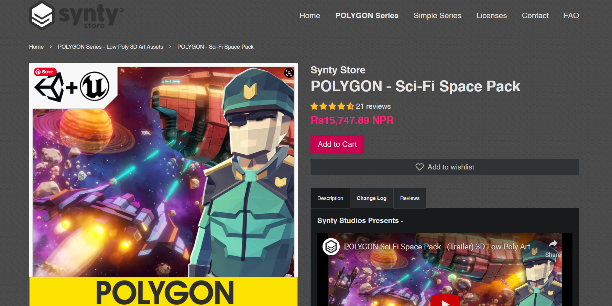

• Supported Platforms: Windows and MacOS

• Supported Unity/ Unreal Versions: 2019.4.28 or higher / 4.26 – 4.27, 5.0

• Download Type: Asset Pack

* Review: It is a low poly asset pack including sci-fi props, weapons, and settings form outer space. The modular section is simple to assemble in a range of ways. It includes detailed props such as drones, escape pods, a space station, and so on. It allows the player to interact with the outside cosmos. The atmosphere appears stylized and gives off a really cosmic vibe that mixes in with the surroundings. The effects, such as the beacon, black hole, and debris, make it incredibly interactive, proving it to be a sci-fi action- packed asset.

Stylized Dungeon Asset

The third and the final asset that was researched was the Stylized Dungeon Asset pack by Synty Studios.

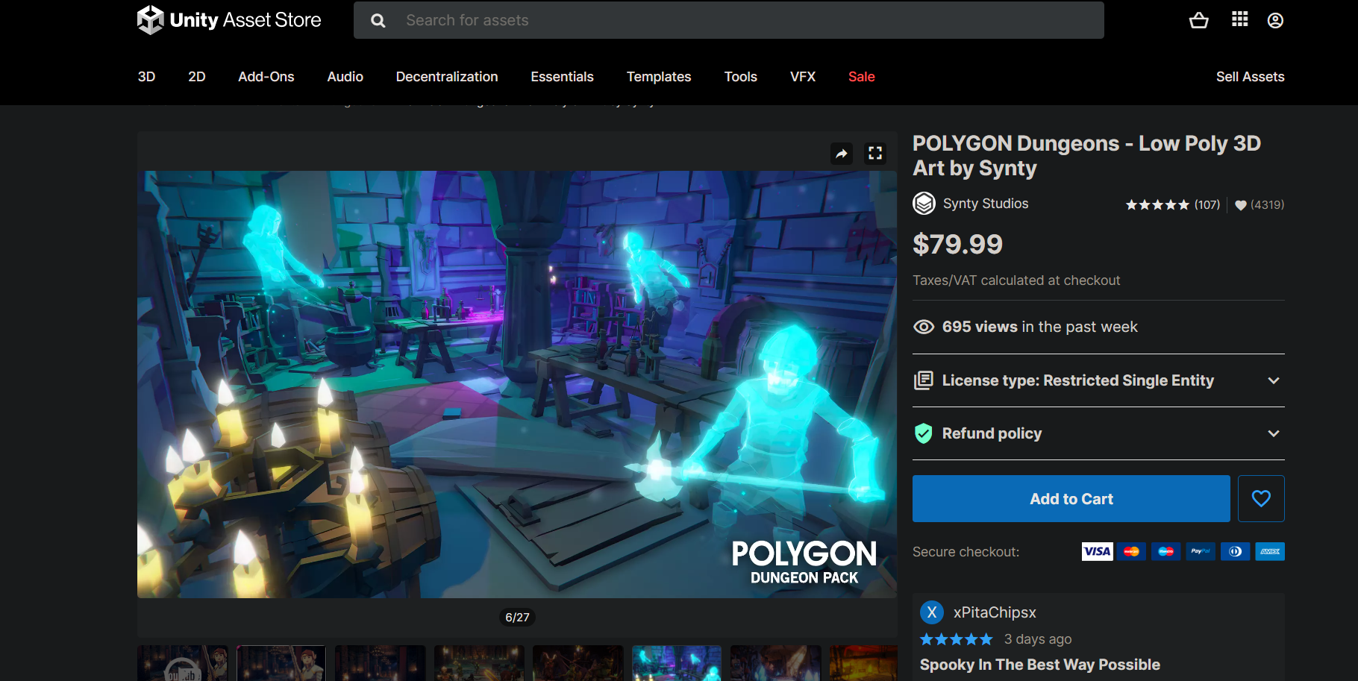

• Supported Platforms: Windows and MacOS

• Supported Unity/ Unreal Versions: 2019.4.28 or higher / 4.26 – 4.27, 5.0

• Download Type: Asset Pack

Review: It is a low poly asset bundle including dungeons which has pack of characters, props, weapons and environment which can be used by the developer to create an epic realm of fantasy low polygonal art game. The asset pack includes modular interior castle set, dungeon entrances, witches brew, weapons, modular goblin camp and to name some few. The atmosphere with the stylized interior brings out the magical realm of fantasy that dives people in it. Low poly weapons design such as hammers, maces, shield provides an additional element to the characters assets.